# Final Project Grading Checklist

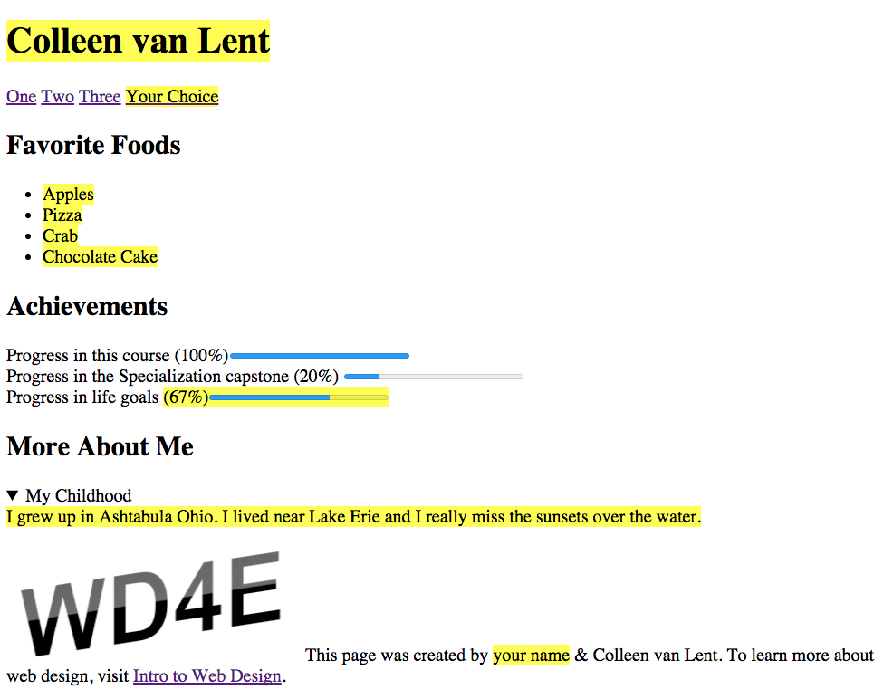

1. **doctype**
2. **head**
3. **body**

* **nav -- add four links, they can go to anywhere you like or nowhere at all**
* **section - Favorite Foods**
* **section - Achievements**
* **section - More About Me**

4**. footer - The image from the footer can be found at my website:**<http://www.intro-webdesign.com/images/newlogo.png>

Practicing proper semantics:

More on nav tag: